Introduction and Background
Utah is changing. In the next twenty-five years, the number of Utahns over age 65 will more than double. Although Utah remains one of the youngest states in the nation, the demographic shift has the potential to affect every aspect of state government, from agencies that address housing, to those that address health care, banking, transportation, human services, recreation, and even corrections.
Most individuals over age 65 remain vibrant, contributing members of our community. Few find it necessary to rely on government programs. By planning, the State of Utah can look for opportunities to keep aging individuals engaged, involved, and contributing to the community. At the same time, it can fashion safety nets for the frail and vulnerable in this population that are effective, financially responsible, and compassionate.
In 2006, Governor Jon M. Huntsman asked each department in state government to participate in UTAH 2030. The project was designed to consider how the dramatic increase in Utah’s aging population will affect state government. The process is designed to:
- Gain an understanding of Utah’s changing demographics
- Project the impact of the aging population on each department’s policies, programs, and operations
- Establish realistic and achievable short-term action steps for each department
- Create an optimal fit between the goods and services provided by state agencies and the needs of the people the agencies are serving.
- Minimize the burdens on state agencies caused by an aging population
- Maximize the benefits to the State of Utah of an increasing aging population


An active, engaged senior population will benefit the State of Utah
The Questions

During a facilitated process, every department in the executive branch answered the following series of questions:

- Identify the impact of the increase in Utah’s aging population on your agency. How will the changing demographic affect your agency’s overarching policy direction, program considerations, changing constituency needs, and management concerns?
- If your agency has begun to address the impact of the aging population, describe what you are doing to address or respond to these anticipated changes, including identified priorities, overarching policies, programs, etc?
- What priorities will help your agency be better prepared for the increase in Utah’s aging population?
- What action can your agency take in the next two years to address the priorities you have identified that reflect the impact of the aging population? Consider collaborative approaches among agencies and how such collaboration could fit into an overall state planning process.
- What are the results you expect to achieve through your recommended actions? List several indicators that you can use to measure your agency’s progress in addressing your priorities.
At the conclusion of the process, each department had developed an action plan including concrete, near term action steps.

This process and report will help Utah to be ready for the aging boom that will begin when the oldest members of the baby boom generation turn 65 in 2011 and will continue for decades. The UTAH 2030 process will continue, with agencies reporting on progress and offering a forum for state agencies to come together to prepare for Utah’s aging boom.
Utah Aging Facts

Utah’s aging population is growing quickly. In the next 25 years, the state’s 65-plus population will double, both in number and as a percentage of the state’s population.

This change in the aging population will have implications across state government, as discussed in Summary of Briefs. Possible impacts include:

- Negative impacts on the state government workforce
- Challenges to the public sector workforce
- Road design considerations
- Protective measures to prevent exploitation of the aging population
- Increasing numbers of individuals relying on safety net programs
- Increasing reliance on technology to serve more individuals with finite resources

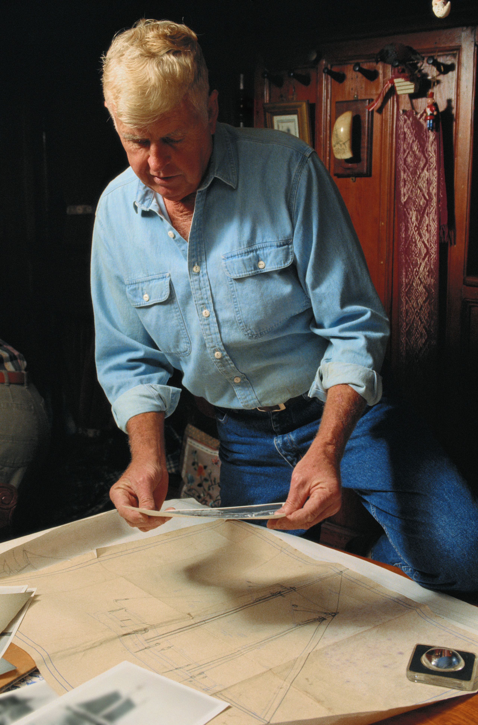

Delaying the retirement of older workers could help to address projected workforce shortages in a number of state agencies, such as the Department of Administrative Services, while improving the financial outlook for those individuals when they do retire.
Utah’s Population Pyramid

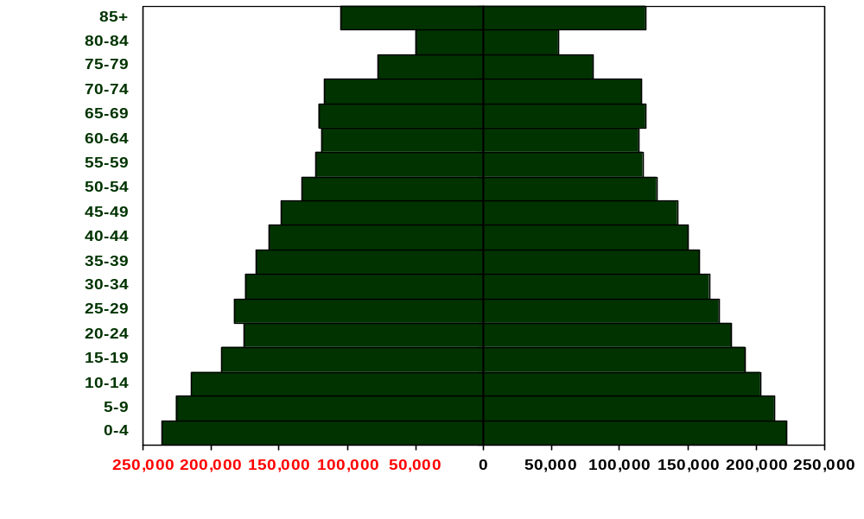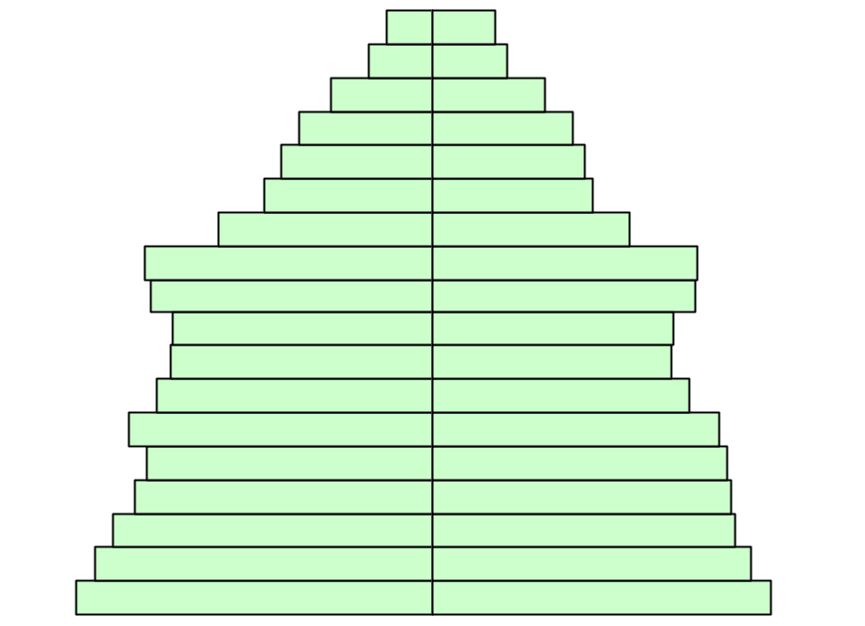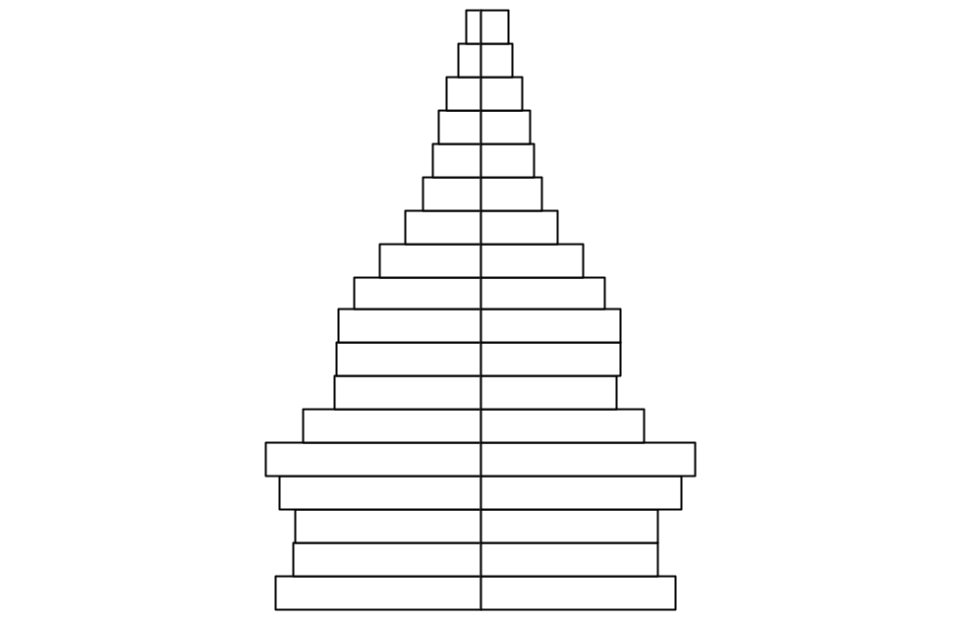
Female
Male
2000
2050
2030

When geographers want to examine the structure of a population and the potential for growth in that population, they turn to a basic tool in demography: the population pyramid. Just as a builder uses a blueprint for depicting the structure of a house, a geographer uses a population pyramid as a blueprint for interpreting the dynamics of a population.

National Geographic

Utah’s population pyramid will change quite dramatically between 2000 and 2050. In theory, a population pyramid would be widest at the bottom and narrowed to a point at the top if most population growth is occurring through natural increase. Utah’s population pyramid shows a change in the dynamics of aging between 2000 and 2050. The unprecedented growth in the 85+ population will create in an inversion of the pyramid between 2030 and 2050.

Utah’s Dependency Ratio
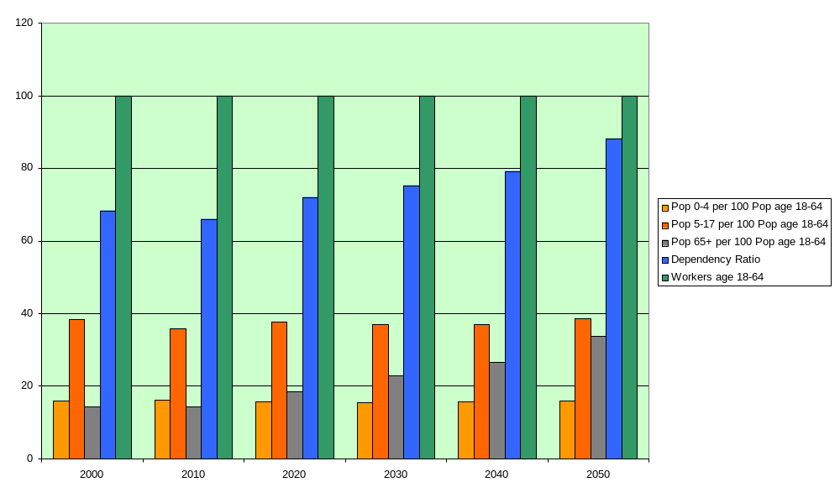

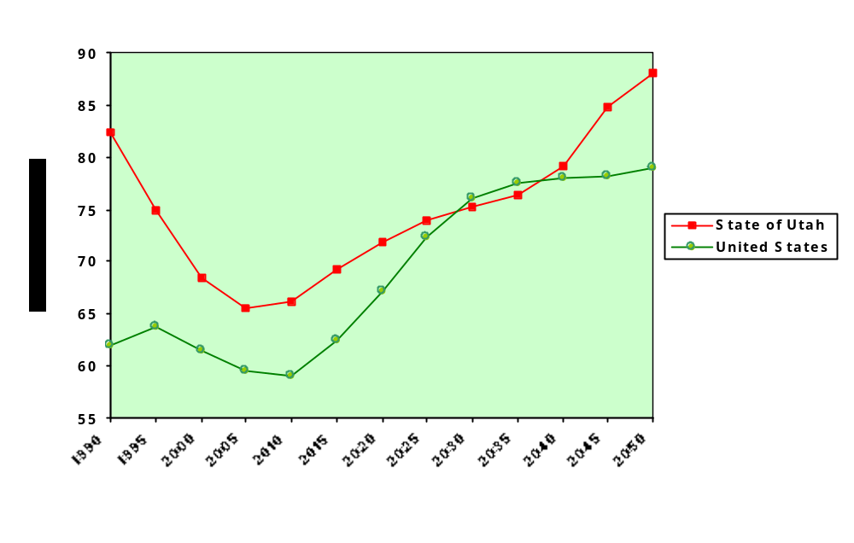Dependency ratios can reflect the economic health of a community. The higher the dependency ratio, the more individuals in the community who are, at least theoretically, dependent on the working age population. Higher dependency ratios are viewed as economic threats. As the following chart shows, Utah’s dependency ratio is currently higher than the U.S. dependency ratio, and it is projected to shoot well above the US dependency ratio beginning around 2040.

Source: 2005 Baseline Projections, GOPB

While Utah’s young population may help to offset some potential challenges of the increase in the aging population, the under age 18 population will continue to place demands on state resources.
Utah’s 85+ Population

When considering the impact of a state’s aging population on safety net programs, the 85+ population is one indicator of potential burden, as this population is most likely to need to rely on safety net programs than other older persons.

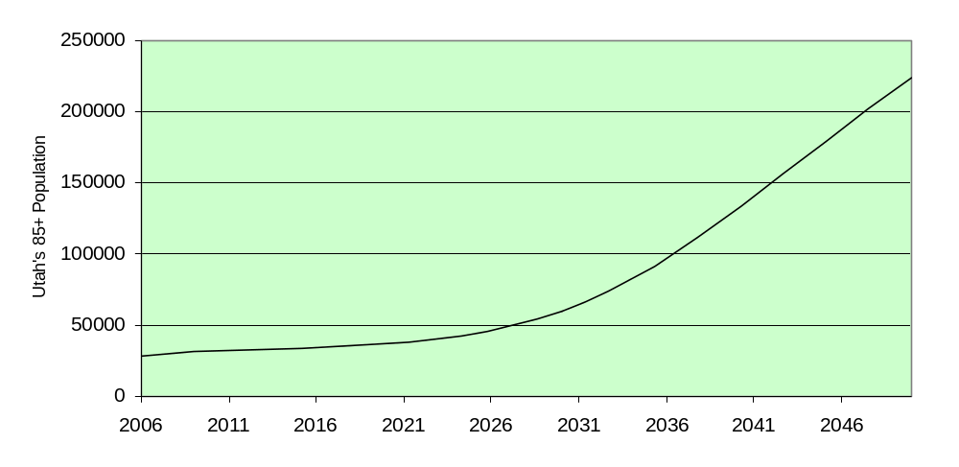
Utah’s 85+ population will steady growth into the 2020’s. Beginning in the middle of that decade, Utah will see a dramatic spike in the 85+ population. By 2050, the 85+ population is projected to be 8 times larger than it was in 2006.



Those who reach age 85 and beyond are increasingly likely to be frail and in need of assistance. Although those aged 85+ are only 13% of the state’s 65+ population, nearly 40% of the 65+ Medicaid recipients living in nursing facilities are 85 and older.

Unless otherwise indicated, all charts in this section are based on 2005 U.S. Census Projections

